Module 3 Assignment – Big Data Visualization on Scale

AD 688 – Web Analytics
Zifan (Oliver) Chen
2026-03-01

Repository
GitHub Repository HTTPS URL:
https://github.com/OliverC17/OliverC17.github.io

Section 2 – Industry Salary Distribution (Box Plot)
[Missing image file: /home/ubuntu/OliverC17.github.io/_site/Assignment 03/figures/Section2_boxplot.png]
Key Insights:
Across the top 15 NAICS2 industries, full-time positions (32+ hours) consistently demonstrate higher median starting salaries compared to both part-time categories, indicating that compensation premiums are strongly associated with full-time employment status.
Industries such as Information, Finance, and Professional Services exhibit both higher central salary distributions and more extreme upper-end outliers, while sectors like Retail Trade and Other Services show comparatively lower medians and narrower interquartile ranges.
Note: The box plot displays SALARY_FROM values (after removing missing and zero entries) grouped by NAICS2 industry and segmented by employment type.

Section 3 – Specialized Occupation (Bubble Chart)
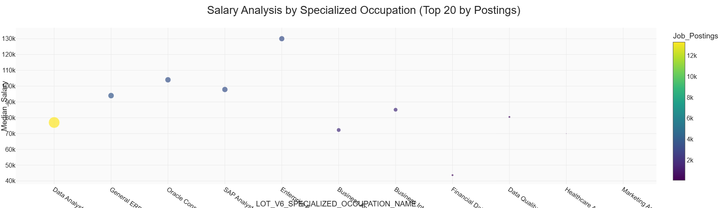
Key Insights:
Among the top specialized occupations within the Business Intelligence domain, enterprise-level and platform-specific roles (e.g., ERP/Oracle/SAP) tend to exhibit higher median salaries, indicating compensation premiums for advanced or specialized expertise.
Data Analyst roles show the highest posting volume but moderate median compensation, suggesting strong market demand with a broader entry-level representation.
Note: Bubble size represents total job postings; the y-axis reflects the median SALARY_FROM based on non-null salary records.

Section 4 – Education Level (Scatter Plots)

Associate or Lower
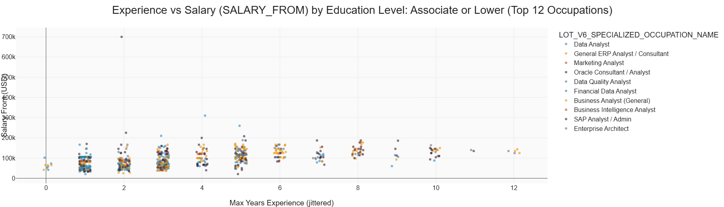
Key Insights:
For roles requiring an associate degree or lower, salaries are generally concentrated in the $40k–$90k range across most occupations.
While salary tends to increase modestly with additional experience, the growth slope appears relatively moderate compared to higher education levels.
Technical specialization (e.g., ERP/enterprise roles) can still command higher upper-bound salaries even at lower formal education levels.

Bachelor
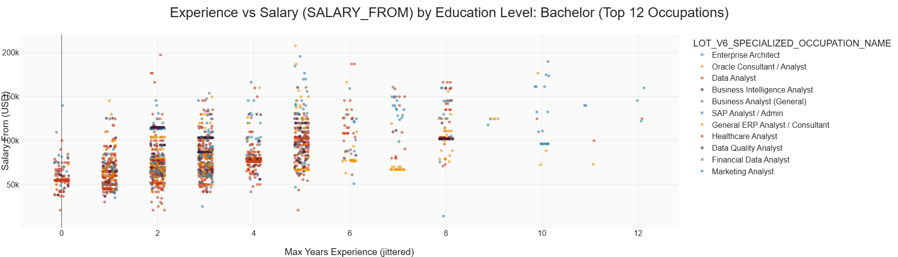
Key Insights:
Bachelor-level positions show a clearer positive relationship between experience and salary, with compensation increasingly clustering above $80k beyond 3–5 years.
Specialized technical roles (e.g., Enterprise Architect, SAP/Oracle-related roles) demonstrate higher salary ceilings.
Salary dispersion widens relative to the associate group, suggesting stronger differentiation by role complexity and skills.

Master
[Missing image file: /home/ubuntu/OliverC17.github.io/_site/Assignment 03/figures/Section4_master.png]
Key Insights:
Master’s degree roles show higher median salary levels and greater variability, with several occupations exceeding $150k at higher experience levels.
Salary progression appears steeper in the early-to-mid career range (roughly 3–6 years), suggesting advanced education may accelerate compensation growth.
High-end outliers indicate premium opportunities for specialized or strategic positions.

PhD
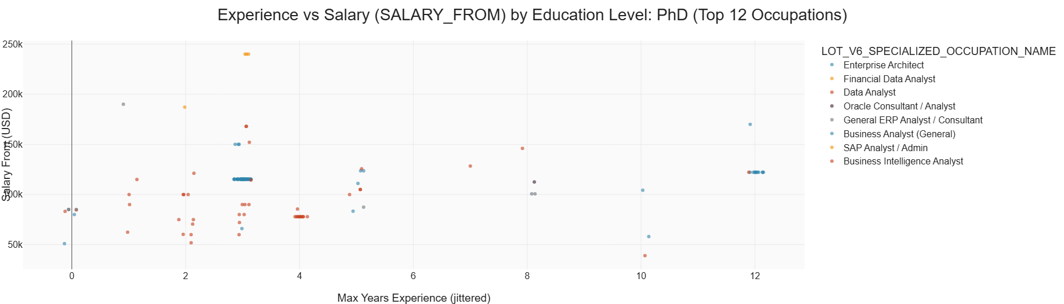
Key Insights:
PhD-level roles exhibit the highest salary ceilings, though sample sizes tend to be smaller.
Compensation is less tightly clustered and shows substantial dispersion, consistent with niche and senior-level roles.
Experience remains important, while advanced credentials may enable access to higher-paying research-intensive or strategic positions.

Section 5 – Remote Work Type (Scatter + Histogram)

Remote
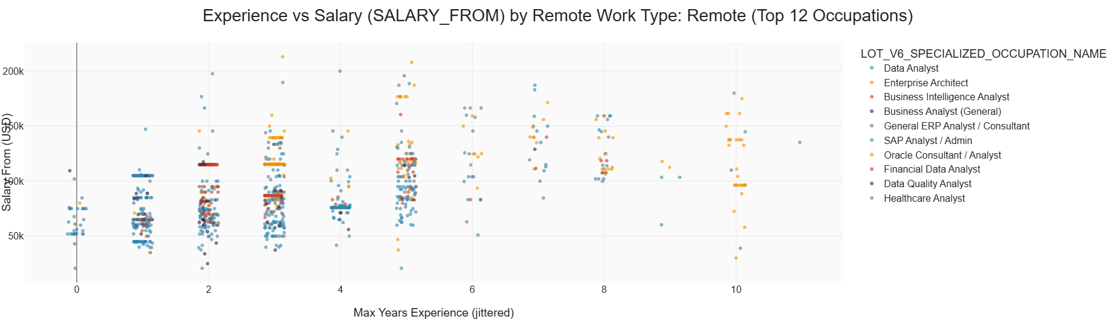
Key Insights:
Remote roles show salaries that generally increase with experience, with many mid-to-senior positions clustering between $90k and $150k.
Platform-specific roles (e.g., Enterprise/ERP) appear more frequently at higher salary levels, indicating specialization premiums.
Dispersion suggests remote opportunities span both mid-level and advanced analytical roles.

Hybrid
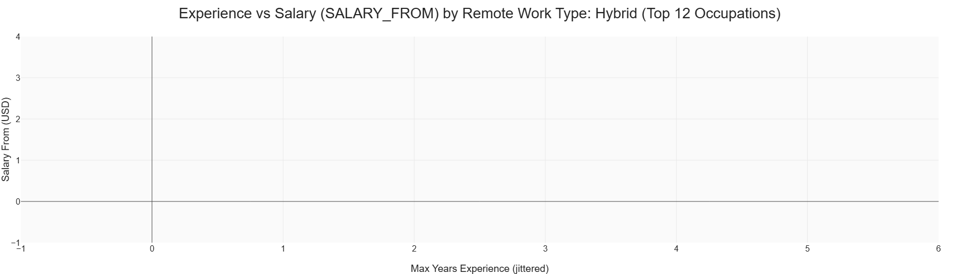
Key Insights:
Hybrid roles appear limited in sample size compared to remote and onsite categories.
Salary distribution is more concentrated, with fewer extreme high-end outliers, suggesting more standardized compensation bands for hybrid roles.

Onsite
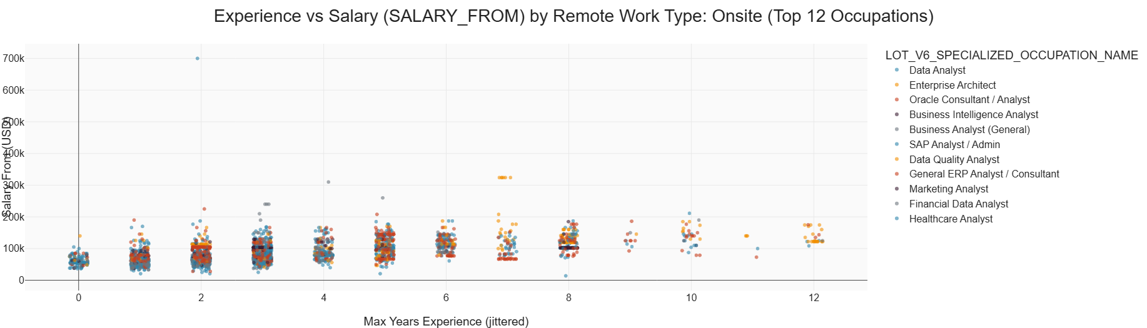
Key Insights:
Onsite roles exhibit a broad salary distribution with visible upper-end outliers, indicating higher compensation potential for specialized or senior positions.
Compared to remote roles, onsite positions show wider dispersion at higher experience levels.
A dense cluster around $70k–$120k suggests this band represents a core compensation range.

Salary Distribution Comparison (Histogram)
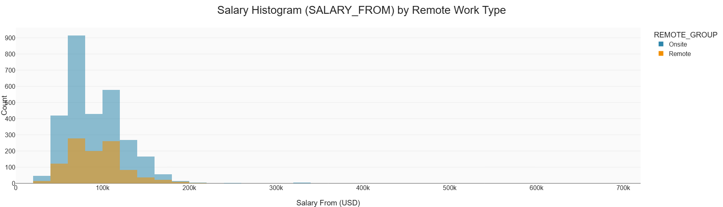
Key Insights:
Both remote and onsite roles share similar central salary ranges (roughly $60k–$120k).
Onsite roles show a heavier right tail with more extreme high-end salaries, while remote roles appear more concentrated in mid-range salary bands.
This suggests comparable baseline pay across arrangements, with onsite offering more extreme upper-bound outcomes.

